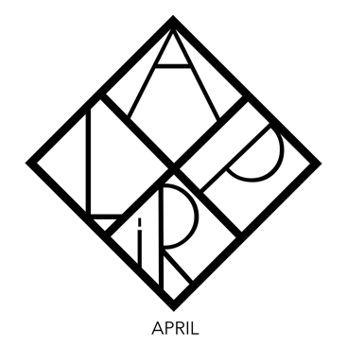

**KSENIYA GOLAND**

[kseniya.goland@gmail.com](mailto:kseniya.goland@gmail.com)

***The connection between the worlds of the past and the future, historical mysteries, flight of imagination - all of that is the world of art, the world of endless discoveries.***

Art historian, writer, and filmmaker.

**EDUCATION**

**BA in Art History** from **Columbia University**, New York, September 2017 **-** July 2020

Select courses (not exhaustive):

• Looking at the Dutch Golden Age

• Masterpieces of Western Art

• Neo Dada and Pop Art

• Nineteenth Century Art

• Twentieth Century Art

• Chekhov on Stage

• Dostoevsky, Tolstoy, and English Novels

**Master of Arts** from **New York University**, New York, September 2020 - Present

Select courses (not exhaustive):

• Independent Study: Gallatin at The Metropolitan Museum of Arts

• Independent Study: Poetry and the Visual Arts

• Theory and Methods in the Arts and Humanities –Traditions of Interpretation

• Material culture and Performance Studies

• The Critic as Artist in the Digital Age

• Film Noir

• Dostoevsky and Modernity

**FURTHER EDUCATION**

**New York University** - New York, New York - 2014-15

• Vermeer: The Beauty and the Mystery of the Light Within (Non-credited, undergrad)

• The Fire of Vincent Van Gogh (Non-credited, undergrad)

• Contemporary Art Scene (Non-credited, undergrad)

• From Duccio to de Kooning at the Metropolitan Museum (Non-credited, undergrad)

• Going for Baroque at the Met (Non-credited, undergrad)

• Face to Face: The Art of the Portrait (Non-credited, undergrad)

**New York University** - New York, New York - 2020 - 2023

**NYU School of Professional Studies Humanities, Arts, & Writing Programs**

• How to Be Modern: From Paris to New York and Beyond

• Friendly rivals: Matisse and Picasso

• Painting Sound: The Intersection of Art and Music

**St. Petersburg State University -** Saint Petersburg, Russia *-*2005-10

• High Renaissance Art and Architecture

• History of Modernism

• Studies in The Art of Renaissance (Credited, undergrad)

• Undergraduate thesis paper: The Art of Giotto Di Bondone (Credited, undergrad)

**Christie School** - New York, New York - 2006

• The History of Japanese Art (Non-credited, Further Ed)

**PROFESSIONAL EXPERIENCE**

**Founder / Creative Director / Lecturer**

[www.april.art](http://www.april.art/) New York, New York - 2020-present

**Tour Leader**

The Metropolitan Museum, New York, New York - 2015 - 2016

*guided tours for children at the Met.*

**Lecturer and Featured Filmographer**

**Lecturer**

The Lofts at Prince, New York, New York - 2015

*“The Art of Jackson Pollock and Vincent Van Gogh”*

**Children’s Art Program Facilitator**

Hermitage Museum, Saint Petersburg, Russia - 2007-08

*Educational program for undergraduates, taught “The World of Dante and Italian Artists from the Renaissance.”*

**International Tour Organizer, Tour Leader**

[The Museum of Anna Akhmatova](https://en.wikipedia.org/wiki/%20Anna_Akhmatova_Literary_and_Memorial_Museum), Saint Petersburg, Russia - 2009

*Branch of the Museum of Fedor Dostoevsky Literary and Memorial Museum*

**LANGUAGES**

English *(fluent)*

Russian *(fluent)*

**HONORS**

Presidential Scholarship, The Pratt Institute - 2016

**PUBLICATIONS**

*Édouard Manet “The First painter of Modernity”*- Imperial Academy of Arts, St. Petersburg, Russia - 2006

*“The Penitent Magdalene” by Titian* - Hermitage Museum, St. Petersburg, Russia - 2005

**FILMOGRAPHY**

*The Angel and Demon of Caravaggio* 2015

Installation*: The Mirrors* 2021

*The Ship by Adrienne Rich* 2022